GitHub: https://github.com/MansoorAZafar/fragments
Running Lint Script
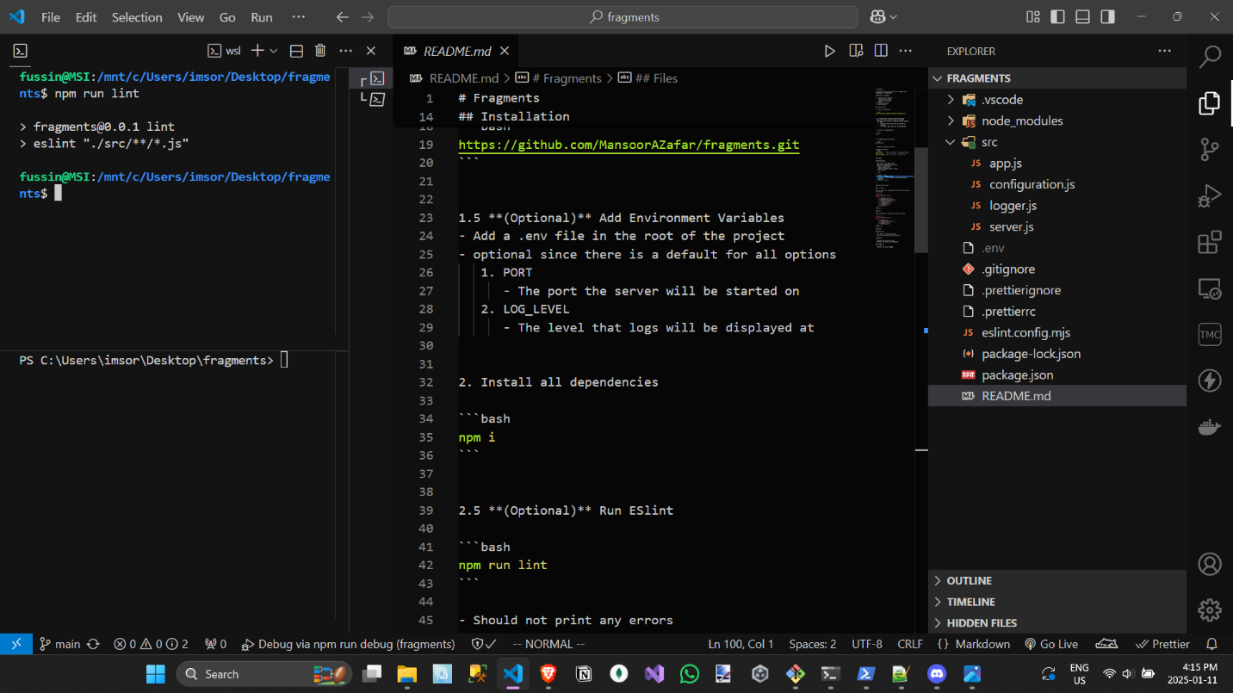
Running Server on Browser at Localhost:8080
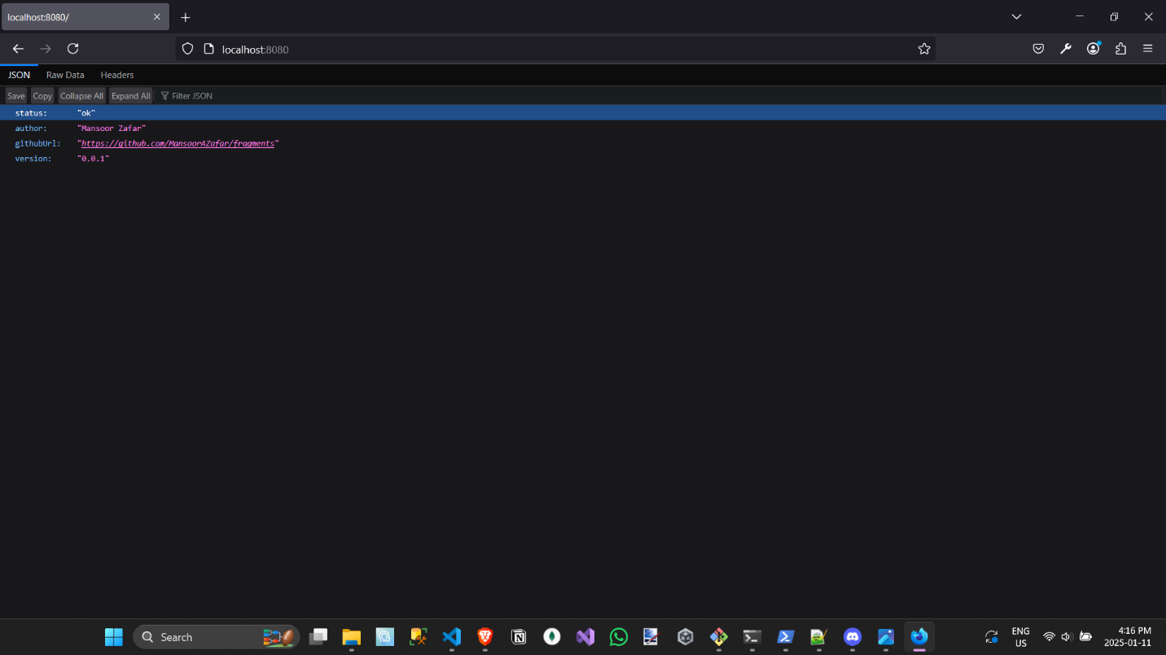
Curl vs Curl.exe & JQ
Curl (needs the full URL)
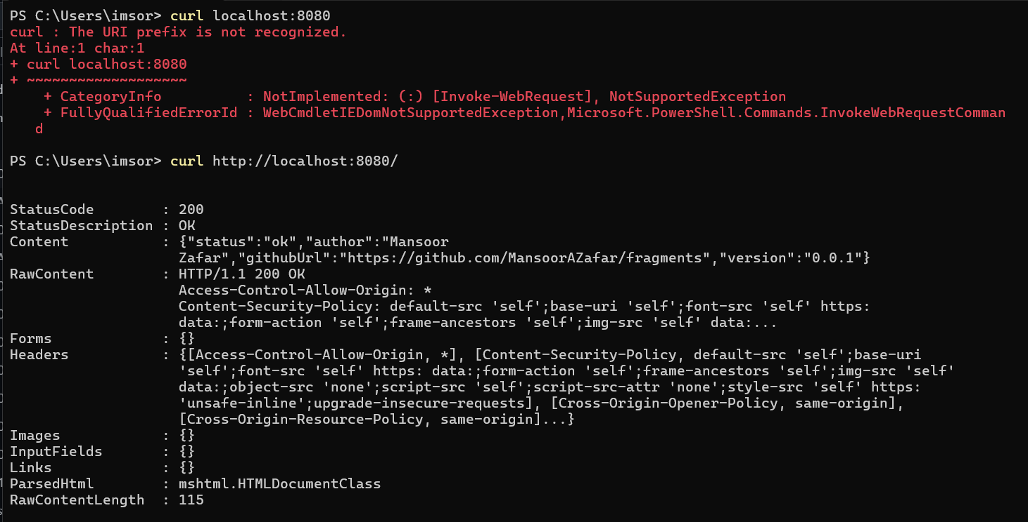
Curl.exe
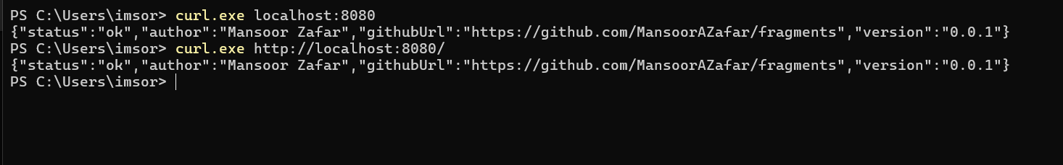
Curl & JQ
(My WSL isn’t working with localhost:8080, it needs the exact IP, so I put that instead)
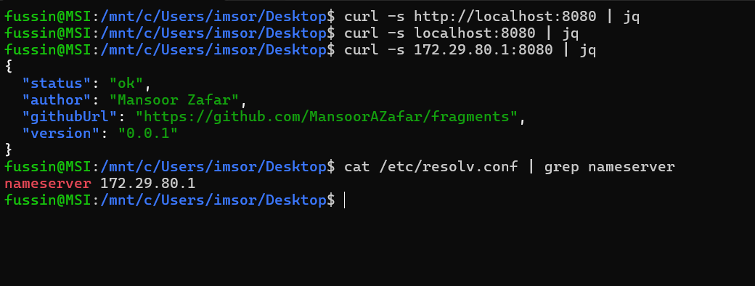
VSCode Breakpoint
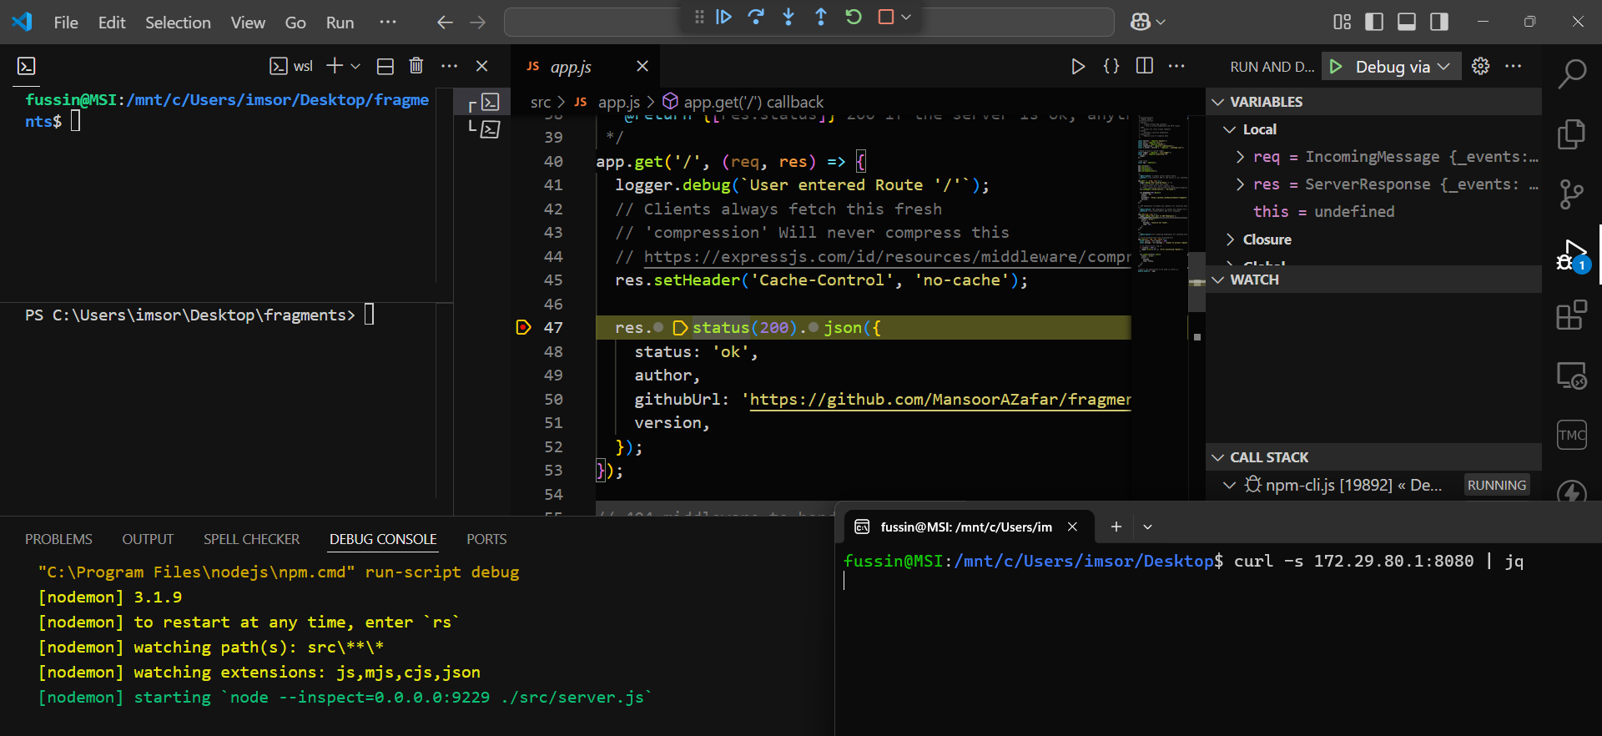
Printing ENV variables
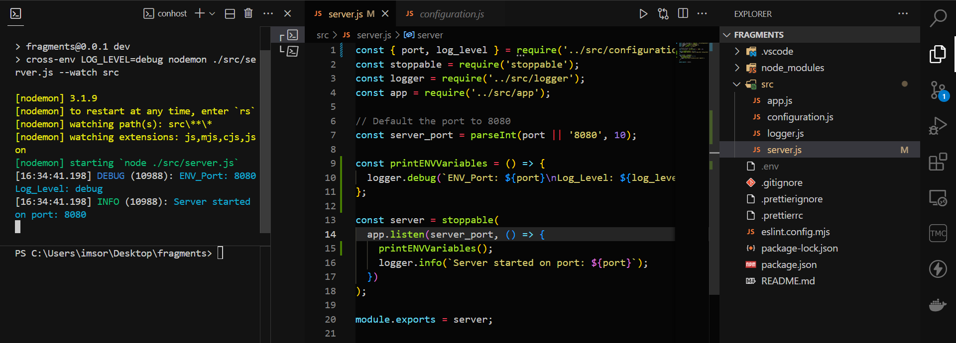
(for reference, here’s a normal run with log level = info)
